In this lesson we will learn about status bar in React native. Now first question could be what is status bar Teacher will tell about it then teacher will tell us how to update its style and also hide and show the status bar Teacher will change some normal properties and how to on the basis of button show and hide the status bar and change its style teacher will discuss some interview

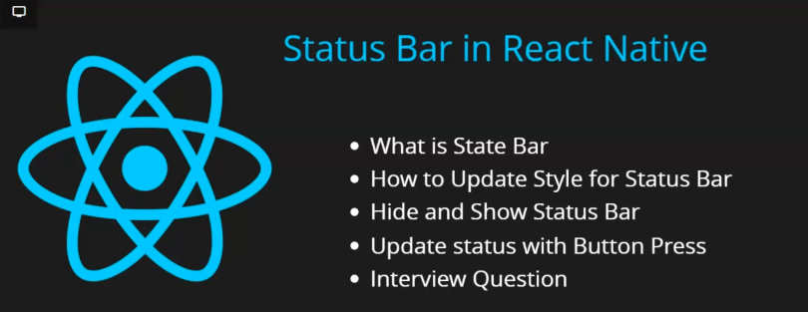

Now we come to the question what is status bar

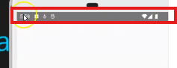

In the emulator in top as marked above is the status bar of grey color of the phone where you can see the time some icons , wifi and symbol of battery This area is called status bar and why it is important and why we need to do its styling Now in our status bar there is some grey color and suppose your app background is green or red or some separate color then that status bar will look different from the app he whole screen is looking different and the status bar is looking different so whenever we design an application then chances are huge that we need to change status bar color so for that IOS and android both operating system give feature that we can hide the status bar and can change its color or contrast so we start with second point so we use normal status bar and then we do style Now we import our Status Bar from react native as shown below in top of the code



One more thing is that in IOS there is also status bar but inside it to change the style in it we need to different code not exactly different but some different so for now we have windows(as Teacher might have misspelled or Android only work on Window ) in a separate lesson teacher may make it in MacOS so that Teacher can show that how in IOS simulator how to change styling of status bar there but for now Teacher can only show only android part

You can use StatusBar as a container component and can also be used as an empty component you don’t need to make it a wrapper as you have seenf in other component we have covered till now

You can use it inside view as shown below



Now we will see some properties suppose you want to change background color and tell the background color you want to change to I change it to red and now output look like below

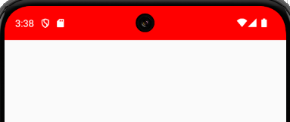

Now you can see the status bar is red in color you can put here any color you want

Now suppose you want to change the style of the status bar so there is property called barstyle

Now there are only two values here you can add either light content or dark content do we add dark content here now the output look below

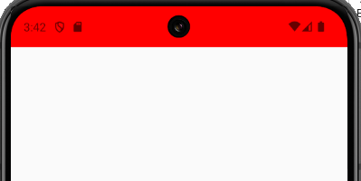

Now you can see all the symbols are in black color now if you do light content then the content will be in white color as it was preciously there is a third value called default which only make the status bar style same to its default if it is light then it will be light and if it is dark then it is dark Now you can even hide the status bar by using hidden property in our status bar and it takes Boolean values of you set it to true then the status bar will be hidden and if set to false then it will be visible



Now we saw basic properties Now how to change something according to state we will see now

Now we make a style property container for Top view and also give button that has a title Toggle Status bar and we make another button with title update style Now to make the button in center we add flex to the container and tell justify-content for center

Now our design code look like below

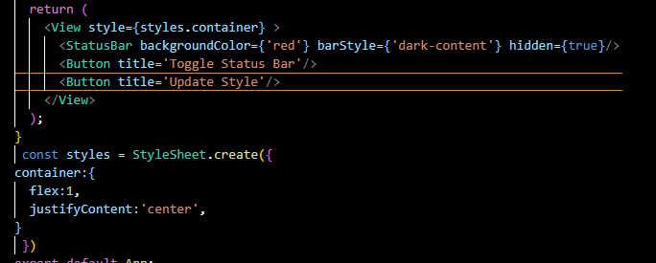

Now our output look like below

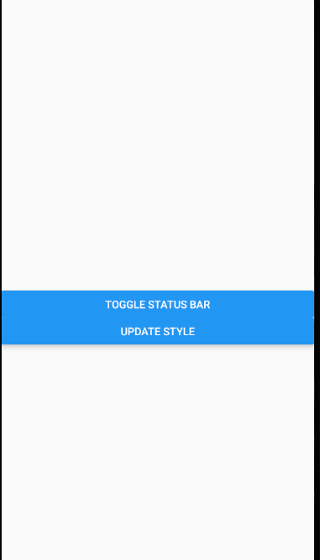

If you want a space between buttons you can add view on both of the and add margin or padding

Now we make a state and name it as hide and make its update function as setHide and and set the hide default value as false now se set hide to the hidden property so the status bar will be visible if the default value as true then it would have been hidden now to make the button toggle status bar to hide and show we add callback function in onpress of button titles as Toggle Status Bar and in callback by update method set the hide to the opposite of value

Now our code look like below

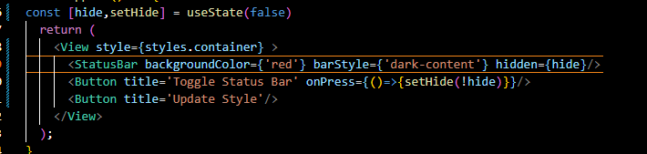

Now our output look like below



Now similarly we make another set that is barStyle and set its update method setBarStyle and its initial value is “default” now we set barStyle property of the Statusbar to the barStyle now suppose the barStyle default value was “dark content” now the symbols in the status bar will be black in color

Now as we have done before in onPress of button titled Update style we set barStyle to the “dark-content” Now our code look like below

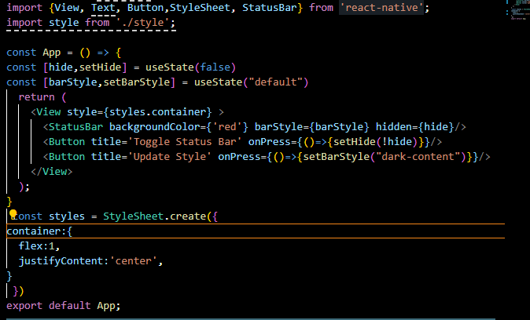

Now our output look like below

**’**

It will not be opposite because we have made toggle the button above it if you wean to make it toggle then you need to use if and else because unlike the first button we don’t have boolean value

So what we have seen in the lesson that how to hide a status bar and how to change background color there are other properties for bar Style which you can check out and how to hide it we also saw it. In the next lesson Teacher will tells us how you can do it in IOS application. In upcoming lesson Teacher will tell us that If we have to add conditional code such that in what to show in IOS and what to show in Android differently so How you will do it. See you in the next lesson.